Command Reference: SortDiversionRights()

Sort diversion rights

StateCU and StateMod Command
Version 3.09.01, 2010-01-26

The SortDiversionRights() command sorts the diversion rights. This is useful to enforce consistency between files and simplify file comparison.

The following dialog is used to edit the command and illustrates the syntax of the command.

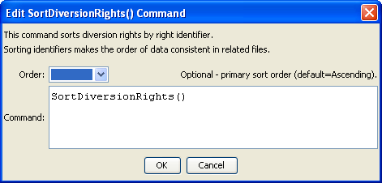
SortDiversionRights
SortDiversionRights() Command Editor

The command syntax is as follows:

SortDiversionRights(Parameter=Value,…)

Command Parameters

Parameter | Description | Default
Order | Indicate the order for the sort. Currently only Ascending is supported. The older Alphabetical is automatically converted to Ascending. | Ascending

This page is intentionally blank.

