Command Reference: SortDiversionStations()

Sort diversion stations

StateMod Command
Version 3.09.01, 2010-02-01

The SortDiversionStations() command sorts the diversion stations by station identifier.

The following dialog is used to edit the command and illustrates the syntax of the command.

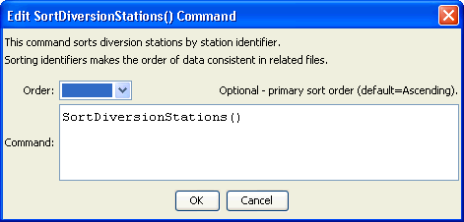
SortDiversionStations
SortDiversionStations() Command Editor

The command syntax is as follows:

SortDiversionStations(Parameter=Value,…)

Command Parameters

Parameter | Description | Default
Order | Indicate the order for the sort. Currently only Ascending is supported. The older Alphabetical is automatically converted to Ascending. | Ascending

