Command Reference: SortInstreamFlowRights()

Sort instream flow rights

StateMod Command
Version 3.09.01, 2010-02-01

The SortInstreamFlowRights() command sorts the instream flow rights by right identifier. This is useful to enforce consistency between files and simplify file comparison.

The following dialog is used to edit the command and illustrates the syntax of the command.

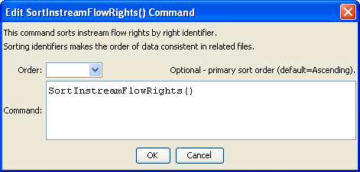
SortInstreamFlowRights
SortInstreamFlowRights() Command Editor

The command syntax is as follows:

SortInstreamFlowRights(Parameter=Value,…)

Command Parameters

Parameter | Description | Default
Order | Indicate the order for the sort. Currently only Ascending is supported. The older Alphabetical is automatically converted to Ascending. | Ascending

This page is intentionally blank.

