Command Reference: SortInstreamFlowStations()

Sort instream flow stations

StateMod Command
Version 3.09.01, 2010-02-01

The SortInstreamFlowStations() command sorts the instream flow stations.

The following dialog is used to edit the command and illustrates the syntax of the command.

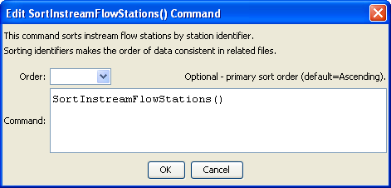
SortInstreamFlowStations
SortInstreamFlowStations() Command Editor

The command syntax is as follows:

SortInstreamFlowStations (Parameter=Value,…)

Command Parameters

Parameter | Description | Default
Order | Indicate the order for the sort. Currently only Ascending is supported. The older Alphabetical is automatically converted to Ascending. | Ascending

