Command Reference: SortIrrigationPracticeTS()

Sort irrigation practice time series

StateCU Command
Version 3.09.01, 2010-02-01

The SortIrrigationPracticeTS() command sorts the irrigation practice time series using the location identifier, and is typically used before writing output.

The following dialog is used to edit the command and illustrates the syntax of the command.

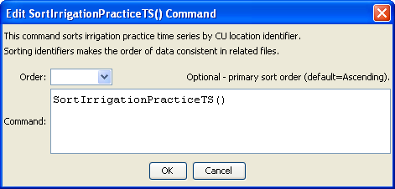
SortIrrigationPracticeTS
SortIrrigationPracticeTS() Command Editor

The command syntax is as follows:

SortIrrigationPracticeTS(Parameter=Value,…)

Command Parameters

Parameter | Description | Default
Order | Indicate the order for the sort. Currently only Ascending is supported. The older Alphabetical will be converted automatically. | Ascending

