Command Reference: SortPenmanMonteith()

Sort Penman-Monteith data

StateCU Command
Version 03.10.00, 2010-04-02

The SortPenmanMonteith() command sorts the Penman-Monteith crop coefficients using the crop name.

The following dialog is used to edit the command and illustrates the syntax of the command.

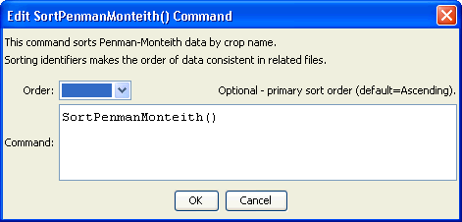
SortPenmanMonteith
SortPenmanMonteith() Command Editor

The command syntax is as follows:

SortPenmanMonteith(Parameter=Value,…)

Command Parameters

Parameter | Description | Default
Order | Indicate the order for the sort for the crop name. Currently only Ascending is supported. The older Alphabetical will be converted automatically. | Ascending

