Command Reference: SortReservoirRights()

Sort reservoir rights

StateMod Command
Version 3.09.01, 2010-02-01

The SortReservoirRights() command sorts the reservoir rights. This is useful to enforce consistency between files and simplify file comparison.

The following dialog is used to edit the command and illustrates the syntax of the command.

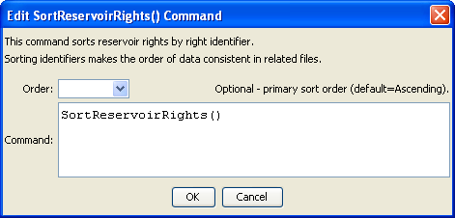
SortReservoirRights
SortReservoirRights() Command Editor

The command syntax is as follows:

SortReservoirRights(Parameter=Value,…)

Command Parameters

Parameter | Description | Default
Order | Indicate the order for the sort. Currently only Ascending is supported. The older Alphabetical is automatically converted to Ascending. | Ascending

