Command Reference: SortReservoirStations()

Sort reservoir stations

StateMod Command
Version 3.09.01, 2010-02-01

The SortReservoirStations() command sorts the reservoir stations by station identifier.

The following dialog is used to edit the command and illustrates the syntax of the command.

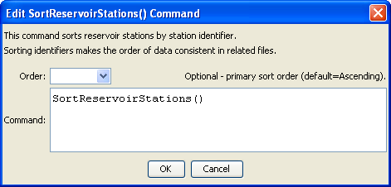
SortReservoirStations
SortReservoirStations() Command Editor

The command syntax is as follows:

SortReservoirStations(Parameter=Value,…)

Command Parameters

Parameter | Description | Default
Order | Indicate the order for the sort. Currently only Ascending is supported. The older Alphabetical is automatically converted to Ascending. | Ascending.

