Command Reference: SortStreamEstimateStations()

Sort stream estimate stations

StateMod Command
Version 3.09.01, 2010-02-01

The SortStreamEstimateStations() command sorts the stream estimate stations by station identifier.

The following dialog is used to edit the command and illustrates the syntax of the command.

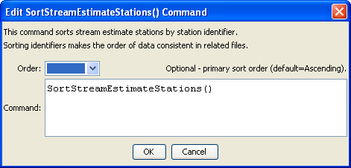
SortStreamEstimateStations
SortStreamEstimateStations() Command Editor

The command syntax is as follows:

SortStreamEstimateStations (Parameter=Value,…)

Command Parameters

Parameter | Description | Default
Order | Indicate the order for the sort. Currently only Ascending is supported. The older Alphabetical is automatically converted to Ascending. | Ascending

