Command Reference: SortStreamGageStations()

Sort stream gage stations

StateMod Command
Version 3.09.01, 2010-02-01

The SortStreamGageStations() command sorts the stream gage stations by identifier.

The following dialog is used to edit the command and illustrates the syntax of the command.

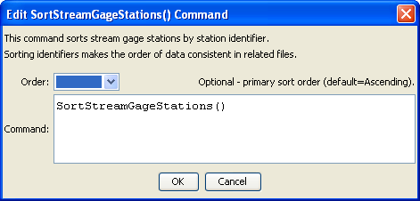
SortStreamGageStations
SortStreamGageStations() Command Editor

The command syntax is as follows:

SortStreamGageStations(Parameter=Value,…)

Command Parameters

Parameter | Description | Default
Order | Indicate the order for the sort. Currently only Ascending is supported. The older Alphabetical is automatically converted to Ascending. | Ascending

