Command Reference: SortWellRights()

Sort well rights

StateMod Command
Version 3.09.00, 2010-01-24

The SortWellRights() command sorts the well rights. This is useful to enforce consistency between files and simplify file comparison.

The following dialog is used to edit the command and illustrates the syntax of the command.

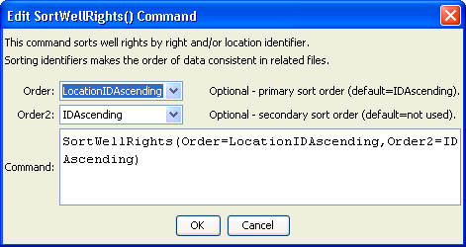
SortWellRights
SortWellRights() Command Editor

The command syntax is as follows:

SortWellRights(Parameter=Value,…)

Command Parameters

Parameter | Description | Default
Order | Indicate the primary sort order, one of:  - IDAscending  - LocationIDAscending (typically specified) | IDAscending
Order2 | Indicate the secondary sort order, one of:  - IDAscending (typically specified)  - LocationIDAscending | None – must be specified. Typically IDAscending is specified.

