Command Reference: SortWellStations()

Sort well stations

StateMod Command
Version 3.09.01, 2010-02-01

The SortWellStations() command sorts the well stations.

The following dialog is used to edit the command and illustrates the syntax of the command.

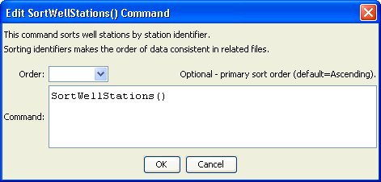
SortWellStations
SortWellStations() Command Editor

The command syntax is as follows:

SortWellStations(Parameter=Value,…)

Command Parameters

Parameter | Description | Default
Order | Indicate the order for the sort. Currently only Ascending is supported. The older Alphabetical is automatically converted to Ascending. | Ascending

