Command Reference: TranslateCropCharacteristics()

Translate crop characteristics crop types from one value to another

StateCU Command
Version 3.08.02, 2010-01-07

The TranslateCropCharacteristics() command translates crop characteristics data. In particular, it converts one crop type to another. Primary uses of the command are:

- A data source may use one variant of the crop type (e.g., ORCHARD W/O COVER but the rest of a StateCU data set uses another type (e.g., ORCHARD_WO_COVER). In this case the command is used simply to change the spelling of a crop type.
- The raw crop data may need to be adjusted to reflect differences in crops, for modeling purposes. For example, the original data may identify pasture (e.g., GRASS_PASTURE) but for modeling the crop type is set to a different value (e.g., GRASS_PASTURE_HA) for high altitude coefficients. The following example illustrates a command of this type.

The following dialog is used to edit the command and illustrates the syntax of the command (for the second case listed above):

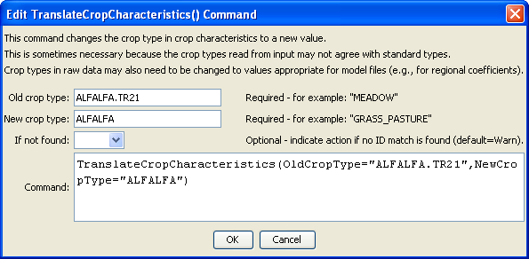
TranslateCropCharacteristics
TranslateCropCharacteristics() Command Editor

The command syntax is as follows:

TranslateCropCharacteristics(Parameter=value,…)

Command Parameters

Parameter | Description | Default
OldCropType | A single crop type identifier to match. This crop type will be replaced with the value for NewCropType. | None – must be specified.
NewCropType | The new crop type to use. | None – must be specified.

The following simple example illustrates how to translate a crop type from the more specific name to a more generic name:

ReadCropCharacteristicsFromHydroBase(CUMethod="BLANEY-CRIDDLE_TR-21")
TranslateCropCharacteristics(OldCropType="ALFALFA.TR21",NewCropType="ALFALFA")

