Command Reference: TranslateCropPatternTS()

Translate crop pattern time series crop types from one value to another

StateCU Command
Version 3.09.01, 2010-02-01

The TranslateCropPatternTS() command translates crop pattern time series data. In particular, it converts one crop type to another. Primary uses of the command are:

- A data source may be using one variant of the crop type (e.g., ORCHARD W/O COVER but the rest of a StateCU data set uses another type (e.g., ORCHARD_WO_COVER). In this case the command is used simply to change the spelling of a crop type.
- The raw crop data may need to be adjusted to reflect differences in crops, for modeling purposes. For example, the original data may identify pasture (e.g., ALFALFA) but for modeling the crop type is set to a different value (e.g., ALFALFA.CCRG) for high altitude coefficients. The following example illustrates a command of this type, using a list file to provide location identifiers at which crop types should be adjusted for the high-altitude crop coefficients (by translating to a different crop type).

If the new crop name is the same as an existing crop name, the time series will be combined to give new totals for the crop. The following dialog is used to edit the command and illustrates the syntax of the command (for the second case listed above):

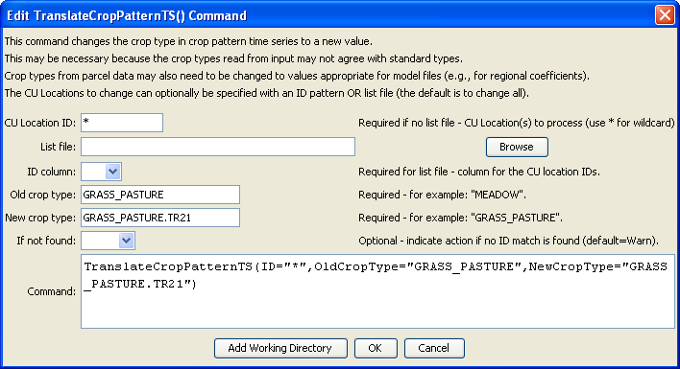
TranslateCropPatternTS
TranslateCropPatternTS() Command Editor

The command syntax is as follows:

TranslateCropPatternTS(Parameter=Value,…)

Command Parameters

Parameter | Description | Default
ID | A single CU Location identifier to match or a pattern using wildcards (e.g., 20*). | None – must be specified.
ListFile | The name of an input file to read, surrounded by double quotes. | If not specified, crop patterns for all locations will be processed.
IDCol | If ListFile is specified, this parameter specifies the column number (1+) containing the CU Location identifiers. | None – must be specified.
OldCropType | A single crop type identifier to match. This crop type will be replaced with the value for NewCropType. | None – must be specified.
NewCropType | The new crop type to use. | None – must be specified.
IfNotFound | Used for error handling, one of the following:  - Fail – generate a failure message if the ID is not matched  - Ignore – ignore (don’t add and don’t generate a message) if the ID is not matched  - Warn – generate a warning message if the ID is not matched | Warn

The following command file illustrates how to create a crop pattern time series file:

# Step 1 - Set output period and read CU locations
SetOutputPeriod(OutputStart="1950",OutputEnd="2006")
ReadCULocationsFromStateCU(InputFile="..\StateCU\cm2006.str")
# Step 2 - Read SW aggregates
SetDiversionSystemFromList(ListFile="colorado_divsys.csv",IDCol=1,
NameCol=2,PartIDsCol=3,PartsListedHow=InRow)
SetDiversionAggregateFromList(ListFile="colorado_agg.csv",IDCol=1,
NameCol=2,PartIDsCol=3,PartsListedHow=InRow)
# Step 3 - Create *.cds file form and read acreage/crops from HydroBase
CreateCropPatternTSForCULocations(ID="*",Units="ACRE")
ReadCropPatternTSFromHydroBase(ID="*")
# Step 4 - Need to translate crops out of HB to include TR21 suffix
# Translate all crops from HB to include .TR21 suffix
TranslateCropPatternTS(ID="*",OldCropType="GRASS_PASTURE",NewCropType="GRASS_PASTURE.TR21")
TranslateCropPatternTS(ID="*",OldCropType="CORN_GRAIN",NewCropType="CORN_GRAIN.TR21")
TranslateCropPatternTS(ID="*",OldCropType="ALFALFA",NewCropType="ALFALFA.TR21")
…similar commands omitted…
# Step 5 - Translate crop names
# use high-altitude coefficients for structures with more than 50% of
# irrigated acreage above 6500 feet
TranslateCropPatternTS(ListFile="cm2005_HA.lst",IDCol=1,
OldCropType="GRASS_PASTURE.TR21",NewCropType="GRASS_PASTURE.DWHA")
# Step 6 - Fill Acreage
# Fill SW structure acreage backword from 1999 to 1950
# Fill acreage forward for all structures from 2000 to 2006
FillCropPatternTSRepeat(ID="*",CropType="*",FillStart=1950,FillEnd=1993,FillDirection=Backward)
FillCropPatternTSRepeat(ID="*",CropType="*",FillStart=1993,FillEnd=1999,FillDirection=Forward)
FillCropPatternTSRepeat(ID="*",CropType="*",FillStart=2000,FillEnd=2006,FillDirection=Forward)
# Step 7 - Write final *.cds file
WriteCropPatternTSToStateCU(OutputFile="..\StateCU\cm2006.cds",
WriteCropArea=True,WriteHow=OverwriteFile)
# Check the results
CheckCropPatternTS(ID="*")
WriteCheckFile(OutputFile="cm2006.cds.StateDMI.check.html")

