Command Reference: TranslatePenmanMonteith()

Translate Penman-Monteith crop types from one value to another

StateCU Command
Version 3.10.00, 2010-04-02

The TranslatePenmanMonteith() command translates Pennman-Monteith data. In particular, it converts one crop type to another. Primary uses of the command are:

- A data source may use one variant of the crop type (e.g., ORCHARD W/O COVER but the rest of a StateCU data set uses another type (e.g., ORCHARD_WO_COVER). In this case the command is used simply to change the spelling of a crop type.
- The raw crop data may need to be adjusted to reflect differences in crops, for modeling purposes. For example, the original data may identify pasture (e.g., GRASS_PASTURE) but for modeling the crop type is set to a different value (e.g., GRASS_PASTURE.ASCE) for ASCE standardized coefficients. The following example illustrates a command of this type.

The following dialog is used to edit the command and illustrates the syntax of the command (for the second case listed above):

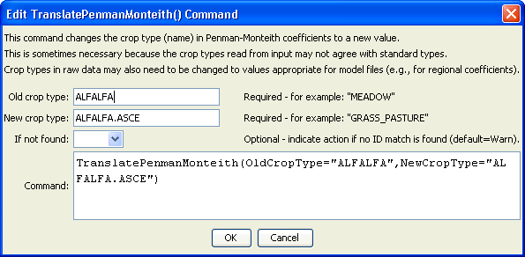
TranslatePenmanMonteith
TranslatePenmanMonteith() Command Editor

The command syntax is as follows:

TranslatePenmanMonteith(Parameter=Value,…)

Command Parameters

Parameter | Description | Default
OldCropType | A single crop type identifier to match. This crop type will be replaced with the value for NewCropType. | None – must be specified.
NewCropType | The new crop type to use. | None – must be specified.

The following simple example illustrates how to translate a crop type:

ReadPenmanMonteithFromHydroBase(PenmanMonteithMethod="PENMAN-MONTEITH_ALFALFA")
TranslatePenmanMonteith(OldCropType="ALFALFA",NewCropType=”ALFALFA.ASCE")

