Command Reference: WriteBlaneyCriddleToList()

Write Blaney-Criddle crop coefficients data to a delimited file

StateCU Command
Version 3.08.02, 2010-01-07

The WriteBlaneyCriddleToList() command writes Blaney-Criddle crop coefficients data to a delimited file. The following dialog is used to edit the command and illustrates the syntax of the command.

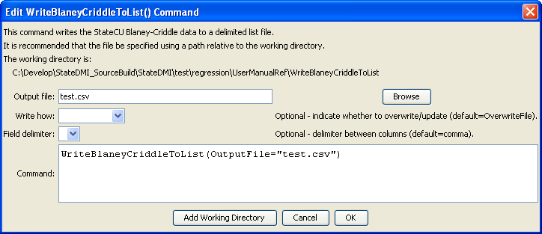
WriteBlaneyCriddleToList
WriteBlaneyCriddleToList() Command Editor

The command syntax is as follows:

WriteBlaneyCriddleToList(Parameter=Value,…)

Command Parameters

Parameter | Description | Default
OutputFile | The name of the output file to write, surrounded by double quotes. | None – must be specified.
WriteHow | OverwriteFile if the file should be overwritten or UpdateFile if the file should be updated, resulting in the previous header being carried forward. | OverwriteFile
Delimiter | The delimiter character to use between columns. | Comma

The following example illustrates how to process crop characteristics data from HydroBase:

ReadBlaneyCriddleFromHydroBase(BlaneyCriddleMethod="BLANEY-CRIDDLE_TR-21")
WriteBlaneyCriddleToList(OutputFile="test.lst")

