Command Reference: WriteBlaneyCriddleToStateCU()

Write Blaney-Criddle crop coefficients data to a StateCU file

StateCU Command
Version 3.08.02, 2010-01-07

The WriteBlaneyCriddleToStateCU() command writes Blaney-Criddle crop coefficients that have been defined to a StateCU Blaney-Criddle crop coefficients file.

The following dialog is used to edit the command and illustrates the syntax of the command.

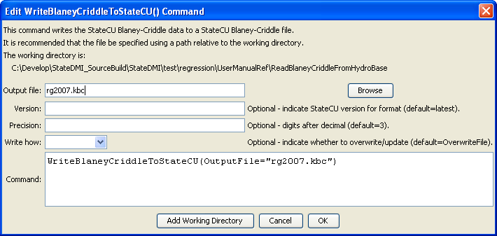
WriteBlaneyCriddleToStateCU
WriteBlaneyCriddleToStateCU() Command Editor

The command syntax is as follows:

WriteBlaneyCriddleToStateCU(Parameter=value,…)

Command Parameters

Parameter | Description | Default
OutputFile | The name of the output file to write, surrounded by double quotes. | None – must be specified.
Version | The StateCU version, indicating the version of the file format to write. | Write the most current version format.
Precision | The number of digits after the decimal for curve values, used for backward compatibility with older file versions. | 3
WriteHow | OverwriteFile if the file should be overwritten or UpdateFile if the file should be updated, resulting in the previous header being carried forward. | OverwriteFile

The following example command file illustrates how to read Blaney-Criddle coefficients from HydroBase, sort the data, create a StateCU file, and check the results:

StartLog(LogFile="Crops_KBC.StateDMI.log")
#
# StateDMI commands to create the Rio Grande Blaney-Criddle coefficients File
#
# History:
#
# 2004-03-16 Steven A. Malers, RTi Initial version using StateDMI.
# 2007-04-23 SAM, RTi Update for Rio Grande Phase 5.
#
# Step 1 - read data from HydroBase
#
# Read the general Blaney-Criddle coefficients first and then override with Rio Grande
# data.
ReadBlaneyCriddleFromHydroBase(BlaneyCriddleMethod="BLANEY-CRIDDLE_TR-21")
ReadBlaneyCriddleFromHydroBase(BlaneyCriddleMethod="BLANEY-CRIDDLE_RIO_GRANDE")
#
# Step 3 - write the file
#
SortBlaneyCriddle(Order=Ascending)
WriteBlaneyCriddleToStateCU(OutputFile="rg2007.kbc")
#
# Check the results
#
CheckBlaneyCriddle(ID="*")
WriteCheckFile(OutputFile="rg2007.kbc.check.html")

