Command Reference: WriteCULocationsToList()

Write CU Locations data to a delimited file

StateCU Command
Version 3.09.00, 2010-01-24

The WriteCULocationsToList() command writes CU Locations data to a delimited file. The following dialog is used to edit the command and illustrates the syntax of the command.

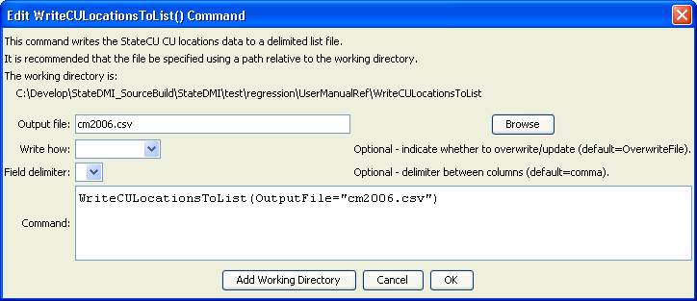
WriteCULocationsToList
WriteCULocationsToList() Command Editor

The command syntax is as follows:

WriteCULocationsToList(Parameter=Value,…)

Command Parameters

Parameter | Description | Default
OutputFile | The name of the output file to write, surrounded by double quotes. | None – must be specified.
WriteHow | OverwriteFile if the file should be overwritten or UpdateFile if the file should be updated, resulting in the previous header being carried forward. | OverwriteFile
Delimiter | The delimiter character to use between columns. | Comma

The following example illustrates how to process CU Locations data from HydroBase, starting with a list of station identifiers, and creating a full list of data:

ReadCULocationsFromList(ListFile="list.csv")
FillCULocationsFromHydroBase(ID="*",CULocType="Structure",Region1Type="County",Region2Type="HUC")
WriteCULocationsToList(OutputFile="test2.lst")

