Command Reference: WriteCULocationsToStateCU()

Write CU Location data to a StateCU file

StateCU Command
Version 3.09.00, 2010-01-24

The WriteCULocationsToStateCU() command writes CU Locations that have been defined to a StateCU structure file. The following dialog is used to edit the command and illustrates the syntax of the command.

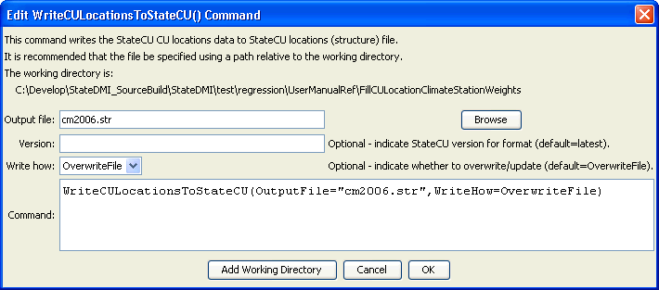
WriteCULocationsToStateCU
WriteCULocationsToStateCU() Command Editor

The command syntax is as follows:

WriteCULocationsToStateCU(Parameter=Value…)

Command Parameters

Parameter | Description | Default
OutputFile | The name of the output file to write, surrounded by double quotes. | None – must be specified.
Version | Indicate the StateCU version, to allow writing file formats for older versions of StateCU. | Write the format for the most current know StateCU version.
WriteHow | OverwriteFile if the file should be overwritten or UpdateFile if the file should be updated, resulting in the previous header being carried forward. | OverwriteFile

