Command Reference: WriteCheckFile()
Write a check file containing a summary of data/processing problems
Version 3.09.00, 2010-01-14

The WriteCheckFile() command summarizes the results of command processing warning/failure messages in a “check file”. This file is useful for reviewing results and for quality control. The check file is essentially a persistent record of any problems that occurred during processing, whereas a full log file contains a sequential list of processing. Multiple check commands can be used as appropriate and one or more check files can be written.

The following dialog is used to edit the command and illustrates the syntax for the command, in this case applied to climate stations data.

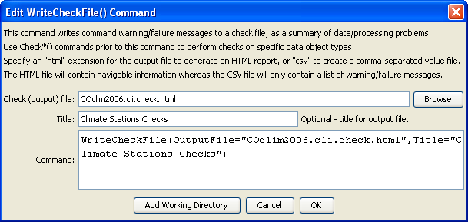
WriteCheckFile
WriteCheckFile() Command Editor

The command syntax is as follows:

WriteCheckFile(Parameter=Value,…)

Command Parameters

Parameter | Description | Default
OutputFile | The name of the check file to create, enclosed in double quotes if the file contains spaces or other special characters. A path relative to the command file containing this command can be specified.  Specify a filename with .html extension to generate an HTML file or .csv to generate a comma-separated value file suitable for use with Excel. The HTML file will contain more information and include navigation links. | None – must be specified.
Title | A title that will be shown in the output file. This is recommended to provide context for results because the default title uses the command file name. | Auto-generated and includes command file name.

