Command Reference: WriteClimateStationsToList()

Write climate station data to a delimited file

StateCU Command
Version 3.08.02, 2010-01-05

The WriteClimateStationsToList() command writes climate stations data to a delimited file. The following dialog is used to edit the command and illustrates the syntax of the command.

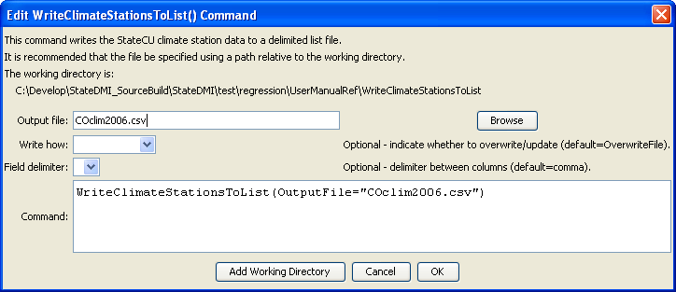
WriteClimateStationsToList
WriteClimateStationsToList() Command Editor

The command syntax is as follows:

WriteClimateStationsToList(Parameter=Value,…)

Command Parameters

Parameter | Description | Default
OutputFile | The name of the output file to write, surrounded by double quotes. | None – must be specified.
WriteHow | OverwriteFile if the file should be overwritten or UpdateFile if the file should be updated, resulting in the previous header being carried forward. | OverwriteFile
Delimiter | The delimiter character to use between columns. | Comma

The following example illustrates how to process climate data from HydroBase, starting with a list of station identifiers, and creating a full list of climate station data:

ReadClimateStationsFromList(ListFile="idonly.csv",IDCol="2")
FillClimateStationsFromHydroBase(ID="*")
WriteClimateStationsToList(OutputFile="COclim2006.csv")

