Command Reference: WriteClimateStationsToStateCU()

Write climate station data to a StateCU file

StateCU Command
Version 3.08.02, 2010-01-05

The WriteClimateStationsToStateCU() command writes climate stations that have been defined to a StateCU climate stations file. The following dialog is used to edit the command and illustrates the syntax of the command.

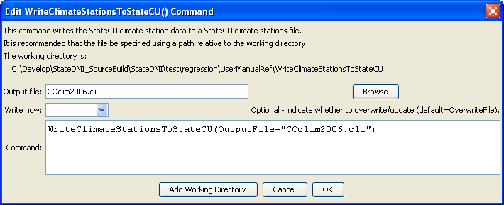
WriteClimateStationsToStateCU
WriteClimateStationsToStateCU() Command Editor

The command syntax is as follows:

WriteClimateStationsToStateCU(Parameter=Value,…)

Command Parameters

Parameter | Description | Default
OutputFile | The name of the output file to write, surrounded by double quotes. | None – must be specified.
WriteHow | OverwriteFile if the file should be overwritten or UpdateFile if the file should be updated, resulting in the previous header being carried forward. | OverwriteFile

The following example command file illustrates how climate stations can be defined and written to a StateCU file:

ReadClimateStationsFromList(ListFile="climsta.lst",IDCol=1)
FillClimateStationsFromHydroBase(ID="*")
SetClimateStation(ID="3016",Region2="14080106",IfNotFound=Warn)
SetClimateStation(ID="1018",Region2="14040106",IfNotFound=Warn)
SetClimateStation(ID="1928",Elevation=6440,IfNotFound=Warn)
SetClimateStation(ID="0484",Region1="MOFFAT",IfNotFound=Add)
WriteClimateStationsToStateCU(OutputFile="COclim2006.cli")

