Command Reference: WriteCropCharacteristicsToStateCU()

Write crop characteristics data to a StateCU file

StateCU Command
Version 3.08.02, 2010-01-07

The WriteCropCharacteristicsToStateCU() command writes crop characteristics data to a StateCU climate crop characteristics file.

The following dialog is used to edit the command and illustrates the syntax of the command.

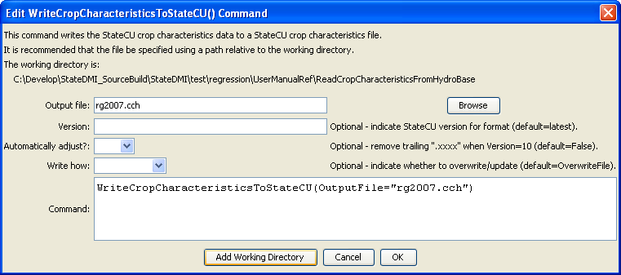
WriteCropCharacteristicsToStateCU
WriteCropCharacteristicsToStateCU() Command Editor

The command syntax is as follows:

WriteCropCharacteristicsToStateCU(Parameter=Value,…)

Command Parameters

Parameter | Description | Default
OutputFile | The name of the output file to write, surrounded by double quotes. | None – must be specified.
Version | Indicate whether output should be formatted for a specific version of StateCU file. | Write the most current version.
AutoAdjust | Automatically adjust the crop names by removing trailing .XXX characters (the period and any trailing characters). This may be needed because current modeling procedures use a longer crop name (e.g., ALFALFA.TR21) whereas older procedures simply used ALFALFA. The conversion is necessary to allow comparison with older files. | False
WriteHow | OverwriteFile if the file should be overwritten or UpdateFile if the file should be updated, resulting in the previous header being carried forward. | OverwriteFile

The following example illustrates how to create a StateCU crop characteristics file with data from HydroBase:

StartLog(LogFile="Crops_CCH.StateDMI.log")
#
# StateDMI commands to create the Rio Grande Crop Characteristics File
#
# History:
#
# 2004-03-16 Steven A. Malers, RTi Initial version using StateDMI.
# 2007-04-22 SAM, RTi Use new directory structure, current
# software and HydroBase.
#
# Step 1 - read data from HydroBase
#
# Read the general TR-21 characteristics first and then override with Rio Grande
# data.
ReadCropCharacteristicsFromHydroBase(CUMethod="BLANEY-CRIDDLE_TR-21")
ReadCropCharacteristicsFromHydroBase(CUMethod="BLANEY-CRIDDLE_RIO_GRANDE")
#
# Step 2 - adjust crop characteristics if needed
# No resets are needed.
#
# Step 3 - write the file
#
WriteCropCharacteristicsToStateCU(OutputFile="rg2007.cch")
#
# Check the results
#
CheckCropCharacteristics(ID="*")
WriteCheckFile(OutputFile="rg2007.cch.check.html")

