Command Reference: WriteDelayTablesDailyToList()

Write delay tables (daily) data to a delimited file

StateMod Command
Version 3.09.01, 2010-02-04

The WriteDelayTablesDailyToList() command writes daily delay tables that have been defined to a delimited file. The following dialog is used to edit the command and illustrates the syntax of the command.

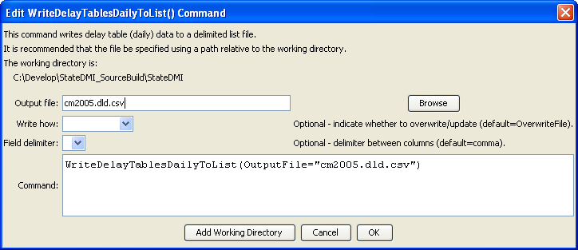
WriteDelayTablesDailyToList
WriteDelayTablesDailyToList() Command Editor

The command syntax is as follows:

WriteDelayTablesDailyToList(Parameter=Value,…)

Command Parameters

Parameter | Description | Default
OutputFile | The name of the output file to write, surrounded by double quotes. | None – must be specified.
Delimiter | The character used to delimit columns in the file. | , (comma)
WriteHow | OverwriteFile if the file should be overwritten or UpdateFile if the file should be updated, resulting in the previous header being carried forward. | OverwriteFile

