Command Reference: WriteDelayTablesDailyToStateMod()

Write delay tables (daily) data to a StateMod file

StateMod Command
Version 3.09.01, 2010-02-01

The WriteDelayTablesDailyToStateMod() command writes daily delay tables that have been defined to a StateMod delay tables file. The following dialog is used to edit the command and illustrates the syntax of the command.

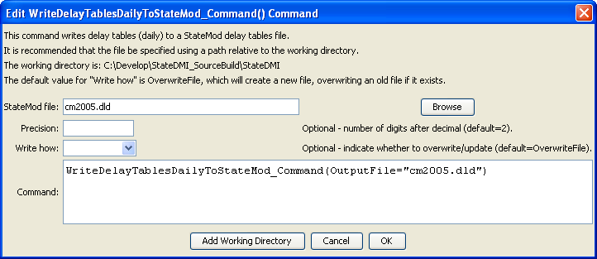
WriteDelayTablesDailyToStateMod
WriteDelayTablesDailyToStateMod() Command Editor

The command syntax is as follows:

WriteDelayTablesDailyToStateMod(Parameter=Value,…)

Command Parameters

Parameter | Description | Default
OutputFile | The name of the output file to write, surrounded by double quotes. | None – must be specified.
Precision | The number of digits after the decimal point for data values. | 2
WriteHow | OverwriteFile if the file should be overwritten or UpdateFile if the file should be updated, resulting in the previous header being carried forward. | OverwriteFile

