Command Reference: writeDelayTablesToStateCU()

Write delay tables data to a StateCU file

StateCU Command
Version 01.17.00, 2005-01-20, Color, Acrobat Distiller

The writeDelayTablesToStateCU() command writes delay tables that have been defined to a StateCU delay tables file. The following dialog is used to edit the command and illustrates the syntax of the command.

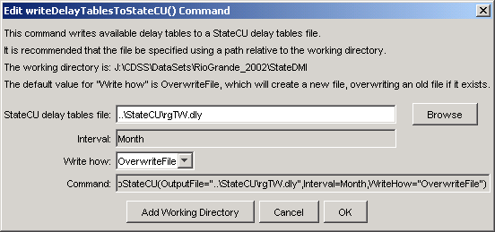
writeDelayTablesToStateCU
writeDelayTablesToStateCU() Command Editor

The command syntax is as follows:

writeDelayTablesToStateCU(param=value,param=value,…)

Command Parameters

Parameter | Description | Default
OutputFile | The name of the output file to write, surrounded by double quotes. | None – must be specified.
WriteHow | OverwriteFile if the file should be overwritten or UpdateFile if the file should be updated, resulting in the previous header being carried forward. | OverwriteFile

