Command Reference: WriteDiversionHistoricalTSMonthlyToStateMod()

Write diversion historical time series (monthly) to a StateMod file

StateMod Command
Version 3.09.01, 2010-02-01

The WriteDiversionHistoricalTSMonthlyToStateMod() command writes diversion historical time series (monthly) to a StateMod diversion historical time series file. The following dialog is used to edit the command and illustrates the syntax of the command.

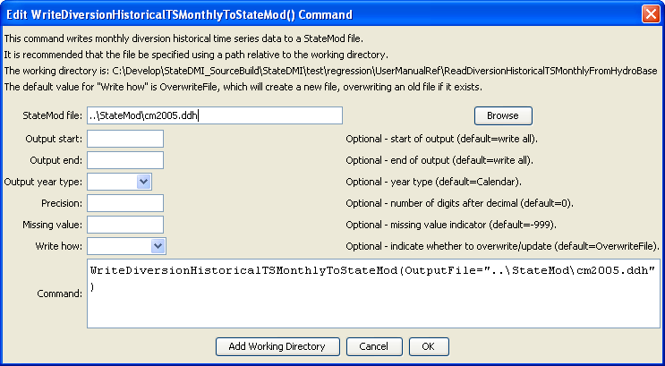
WriteDiversionHistoricalTSMonthlyToStateMod
WriteDiversionHistoricalTSMonthlyToStateMod() Command Editor

The command syntax is as follows:

WriteDiversionHistoricalTSMonthlyToStateMod(Parameter=Value,…)

Command Parameters

Parameter | Description | Default
OutputFile | The name of the output file to write, surrounded by double quotes. | None – must be specified.
OutputStart | The start date to write, using format YYYY-MM or MM/YYYY. | Full period will be written.
OutputEnd | The end date to write, using format YYYY-MM or MM/YYYY. | Full period will be written.
OutputYearType | The output year type to write, one of:  - Calendar – January to December.  - NovToOct – November to October.  - Water – October to September. | Calendar, or the value set by the previous SetOutputYearType() command.
Precision | The number of digits after the decimal to write. | 2
MissingValue | The value to write for missing data. | -999
WriteHow | OverwriteFile if the file should be overwritten or UpdateFile if the file should be updated, resulting in the previous header being carried forward. | OverwriteFile

