Command Reference: WriteDiversionRightsToList()

Write diversion rights data to a delimited file

StateCU and StateMod Command
Version 3.09.00, 2010-01-26

The WriteDiversionRightsToList() command writes diversion rights data to a delimited file.

The following dialog is used to edit the command and illustrates the syntax of the command.

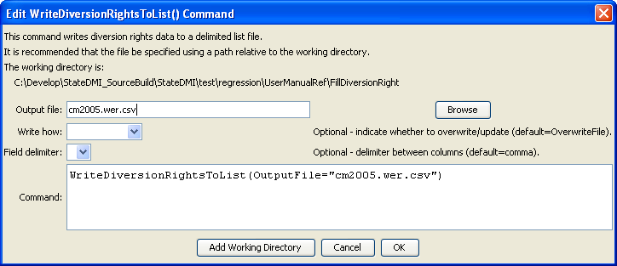
WriteDiversionRightsToList
WriteDiversionRightsToList() Command Editor

The command syntax is as follows:

WriteDiversionRightsToList(param=value,…)

Command Parameters

Parameter | Description | Default
OutputFile | The name of the output file to write, surrounded by double quotes. | None – must be specified.
WriteHow | OverwriteFile if the file should be overwritten or UpdateFile if the file should be updated, resulting in the previous header being carried forward. | OverwriteFile
Delimiter | The delimiter character to use between columns. | Comma

The following example illustrates how to create a list of diversion rights from a list of stations:

ReadDiversionStationsFromList(ListFile="test.csv")
ReadDiversionRightsFromHydroBase(ID="*")
WriteDiversionRightsToList(OutputFile="rights.csv")

