Command Reference: WriteDiversionRightsToStateMod()

Write diversion rights data to a StateMod file

StateCU and StateMod Command
Version 3.09.00, 2010-01-26

The WriteDiversionRightsToStateMod() command writes diversion rights that have been defined to a StateMod diversion rights file. The following dialog is used to edit the command and illustrates the syntax of the command.

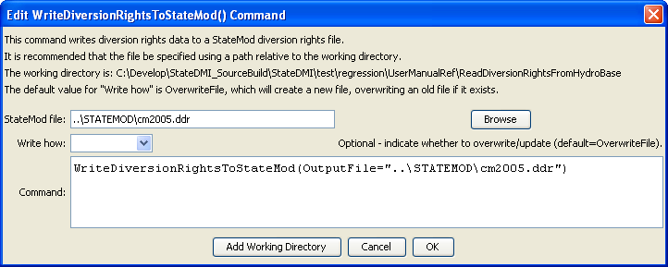
WriteDiversionRightsToStateMod
WriteDiversionRightsToStateMod() Command Editor

The command syntax is as follows:

WriteDiversionRightsToStateMod(Parameter=Value,…)

Command Parameters

Parameter | Description | Default
OutputFile | The name of the output file to write, surrounded by double quotes. | None – must be specified.
WriteHow | OverwriteFile if the file should be overwritten or UpdateFile if the file should be updated, resulting in the previous header being carried forward. | OverwriteFile

This page is intentionally blank.

