Command Reference: WriteDiversionStationsToList()

Write diversion station data to a delimited file

StateMod Command
Version 3.09.01, 2010-02-01

The WriteDiversionStationsToList() command writes diversion stations data to a delimited file. In addition to the main station file, files with suffixes _Collections and _ReturnFlows are written, containing secondary station information.

The following dialog is used to edit the command and illustrates the syntax of the command.

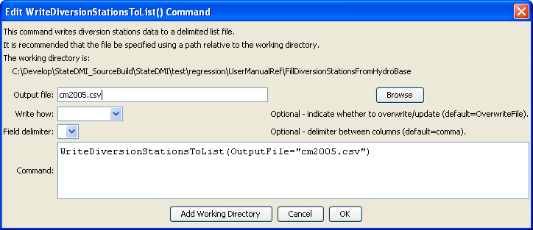
WriteDiversionStationsToList
WriteDiversionStationsToList() Command Editor

The command syntax is as follows:

WriteDiversionStationsToList(Parameter=Value,…)

Command Parameters

Parameter | Description | Default
OutputFile | The name of the output file to write, surrounded by double quotes. | None – must be specified.
WriteHow | OverwriteFile if the file should be overwritten or UpdateFile if the file should be updated, resulting in the previous header being carried forward. | OverwriteFile
Delimiter | The delimiter character to use between columns. | Comma

The following example illustrates how to create a list of diversion stations from a network file:

ReadDiversionStationsFromNetwork(InputFile="cm2005.net")
WriteDiversionStationsToList(OutputFile="cm2005.csv")

