Command Reference: WriteInstreamFlowDemandTSAverageMonthlyToStateMod()

Write instream flow demand time series (average monthly) data to a StateMod file

StateMod Command
Version 3.09.01, 2010-02-02

The WriteInstreamFlowDemandTSAverageMonthlyToStateMod() command writes instream flow demand time series (average monthly) that have been defined to a StateMod instream flow demand time series (average monthly) file. The following dialog is used to edit the command and illustrates the syntax of the command.

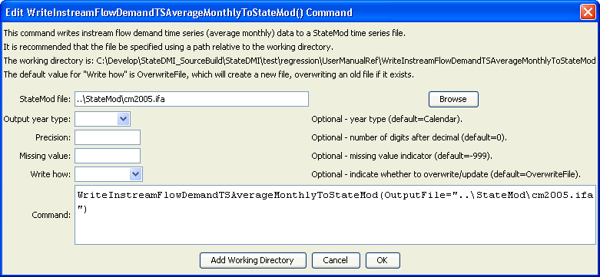
WriteInstreamFlowDemandTSAverageMonthlyToStateMod
WriteInstreamFlowDemandTSAverageMonthlyToStateMod() Command Editor

The command syntax is as follows:

WriteInstreamFlowDemandTSAverageMonthlyToStateMod(Parameter=Value,…)

Command Parameters

Parameter | Description | Default
OutputFile | The name of the output file to write, surrounded by double quotes. | None – must be specified.
OutputYearType | The output year type for the StateMod file. | Calendar
Precision | The number of digits after the decimal point for output values. | 0
MissingValue | The value to use in output for missing data. | -999
WriteHow | OverwriteFile if the file should be overwritten or UpdateFile if the file should be updated, resulting in the previous header being carried forward. | OverwriteFile

