Command Reference: WriteInstreamFlowRightsToList()

Write instream flow rights data to a delimited file

StateMod Command
Version 3.09.01, 2010-02-01

The WriteInstreamFlowRightsToList() command writes instream flow rights data to a delimited file.

The following dialog is used to edit the command and illustrates the syntax of the command.

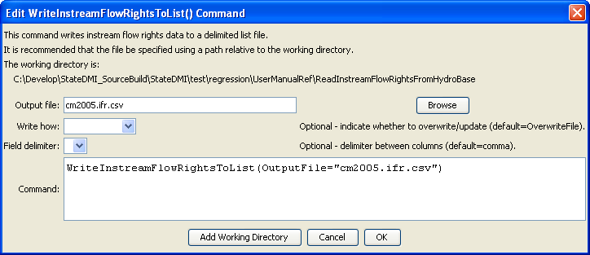
WriteInstreamFlowRightsToList
WriteInstreamFlowRightsToList() Command Editor

The command syntax is as follows:

WriteInstreamFlowRightsToList(Parameter=Value,…)

Command Parameters

Parameter | Description | Default
OutputFile | The name of the output file to write, surrounded by double quotes. | None – must be specified.
WriteHow | OverwriteFile if the file should be overwritten or UpdateFile if the file should be updated, resulting in the previous header being carried forward. | OverwriteFile
Delimiter | The delimiter character to use between columns. | Comma

The following example illustrates how to create a list of instream flow rights from a list of stations:

ReadInstreamFlowStationsFromList(ListFile="cm2005.ifs.csv")
ReadInstreamFlowRightsFromHydroBase(ID="*")
WriteInstreamFlowRightsToList(OutputFile="cm2005.ifr.csv")

