Command Reference: WriteInstreamFlowStationsToList()

Write instream flow station data to a delimited file

StateMod Command
Version 3.09.01, 2010-02-01

The WriteInstreamFlowStationsToList() command writes instream flow stations data to a delimited file.

The following dialog is used to edit the command and illustrates the syntax of the command.

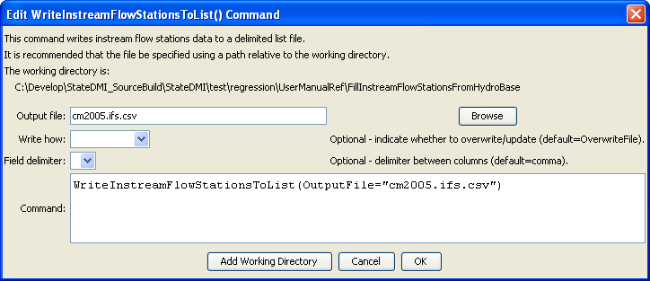
WriteInstreamFlowStationsToList
WriteInstreamFlowStationsToList() Command Editor

The command syntax is as follows:

WriteInstreamFlowStationsToList(Parameter=Value,…)

Command Parameters

Parameter | Description | Default
OutputFile | The name of the output file to write, surrounded by double quotes. | None – must be specified.
WriteHow | OverwriteFile if the file should be overwritten or UpdateFile if the file should be updated, resulting in the previous header being carried forward. | OverwriteFile
Delimiter | The delimiter character to use between columns. | Comma

The following example illustrates how to create a list of instream flow stations from a network file:

ReadInstreamFlowStationsFromNetwork(InputFile="cm2005.net")
WriteInstreamFlowStationsToList(OutputFile="cm2005.ifs.csv”)

