Command Reference: WriteInstreamFlowStationsToStateMod()

Write instream flow stations data to a StateMod file

StateMod Command
Version 3.09.01, 2010-02-01

The WriteInstreamFlowStationsToStateMod() command writes instream flow stations that have been defined to a StateMod instream flow stations file. The following dialog is used to edit the command and illustrates the syntax of the command.

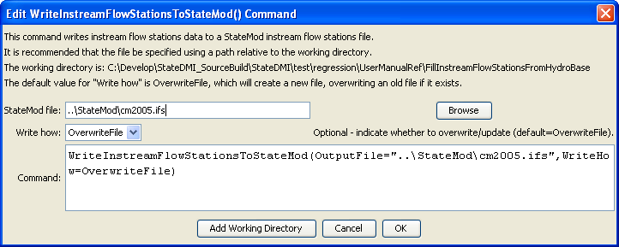
WriteInstreamFlowStationsToStateMod
WriteInstreamFlowStationsToStateMod() Command Editor

The command syntax is as follows:

WriteInstreamFlowStationsToStateMod(Parameter=Value,…)

Command Parameters

Parameter | Description | Default
OutputFile | The name of the output file to write, surrounded by double quotes. | None – must be specified.
WriteHow | OverwriteFile if the file should be overwritten or UpdateFile if the file should be updated, resulting in the previous header being carried forward. | OverwriteFile

