Command Reference: WriteIrrigationPracticeTSToDateValue()

Write irrigation practice time series data to a DateValue file

StateCU Command
Version 01.17.00, 2005-01-20, Color, Acrobat Distiller

The WriteIrrigationPracticeTSToDateValue() command writes irrigation practice time series to a DateValue time series file. This file can be used with TSTool, a spreadsheet, or other software. The following dialog is used to edit the command and illustrates the syntax of the command.

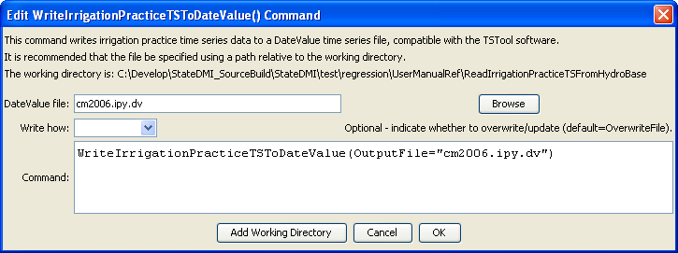
WriteIrrigationPracticeTSToDateValue
WriteIrrigationPracticeTSToDateValue() Command Editor

The command syntax is as follows:

WriteIrrigationPracticeTSToDateValue(Parameter=Value,…)

Command Parameters

Parameter | Description | Default
OutputFile | The name of the output file to write, surrounded by double quotes. | None – must be specified.
WriteHow | OverwriteFile if the file should be overwritten or UpdateFile if the file should be updated, resulting in the previous header being carried forward. | OverwriteFile

