Command Reference: WriteIrrigationPracticeTSToStateCU()

Write irrigation practice time series data to a StateCU file

StateCU Command
Version 3.09.01, 2010-02-01

The WriteIrrigationPracticeTSToStateCU() command writes irrigation practice time series to a StateCU crop pattern file. The following dialog is used to edit the command and illustrates the syntax of the command.

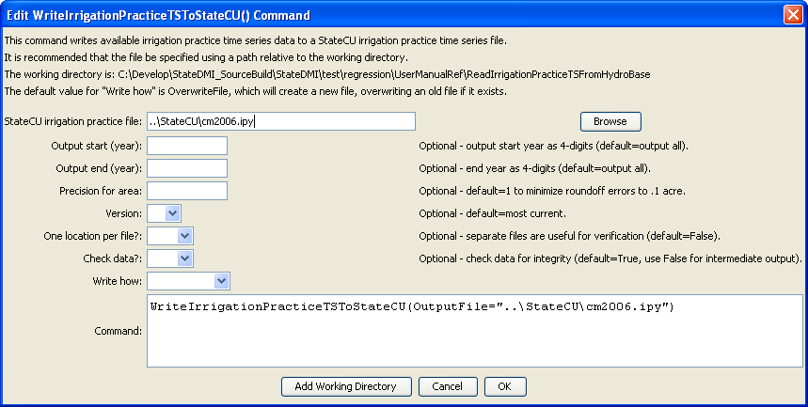
WriteIrrigationPracticeTSToStateCU
WriteIrrigationPracticeTSToStateCU() Command Editor

The command syntax is as follows:

WriteIrrigationPracticeTSToStateCU(Parameter=Value,…)

Command Parameters

Parameter | Description | Default
OutputFile | The name of the output file to write, surrounded by double quotes. | None – must be specified.
OutputStart | Starting year for output. | Write all years.
OutputEnd | Ending year for output. | Write all years.
PrecisionForArea | The number of digits after the decimal point for area values. | 1
Version | Indicate the StateCU version, to control the file format. It is sometimes necessary to write an older version to compare data sets or update an old data set. | Write the most current format.
OneLocationPerFile | Useful for troubleshooting and verification. If True, then each location is written to a separate file. | False
CheckData | Check the data for integrity (do values add up). Set to False if processing preliminary data. | True
WriteHow | OverwriteFile if the file should be overwritten or UpdateFile if the file should be updated, resulting in the previous header being carried forward. | OverwriteFile

