Command Reference: WriteNetworkToStateMod()

Write generalized network data to a StateMod file

StateMod Command
Version 3.09.01, 2010-02-01

The WriteNetworkToStateMod() command writes the generalized network to a StateMod XML network file. The following dialog is used to edit the command and illustrates the syntax of the command.

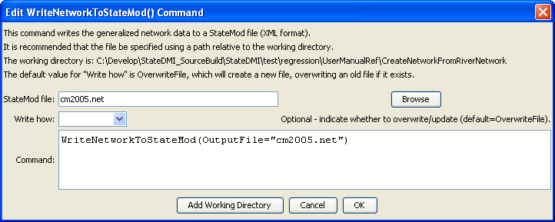
WriteNetworkToStateMod
WriteNetworkToStateMod() Command Editor

The command syntax is as follows:

WriteNetworkToStateMod(Parameter=Value,…)

Command Parameters

Parameter | Description | Default
OutputFile | The name of the output file to write, surrounded by double quotes. | None – must be specified.
WriteHow | OverwriteFile if the file should be overwritten or UpdateFile if the file should be updated, resulting in the previous header being carried forward. | OverwriteFile

The following example command file illustrates how the command might be used:

# Create a generalized XML network from individual StateMod files
# Read the network, which contains upstream to downstream connectivity but does
# not indicate node types
ReadRiverNetworkFromStateMod(InputFile=cm2005.rin)
# Read the stations, which imply the node types
ReadRiverStreamGageStationsFromStateMod(InputFile=cm2005.ris)
ReadRiverDiversionStationsFromStateMod(InputFile=cm2005.dds)
ReadRiverReservoirStationsFromStateMod(InputFile=cm2005.res)
ReadRiverInstreamFlowStationsFromStateMod(InputFile=cm2005.ifs)
ReadRiverWellStationsFromStateMod(InputFile=cm2005.wes)
# To be developed...
#ReadRiverPlanStationsFromStateMod()
ReadRiverStreamEstimateStationsFromStateMod(InputFile=cm2005.ris)
# Now create the generalized network, using the connectivity and node types
CreateNetworkFromRiverNetwork()
# Fill in node names and locations from HydroBase, if any is still missing
FillNetworkFromHydroBase()
# Write the generalized network
WriteNetworkToStateMod(OutputFile="cm2005.net")
# Check for errors (the following is not yet implemented)
#CheckNetwork()
WriteCheckFile(OutputFile="cm2005.net.check.html")

