Command Reference: WriteOperationalRightsToStateMod()

Write operational rights data to a StateMod file

StateMod Command
Version 3.12.00, 2010-12-14

The WriteOperationalRightsToStateMod() command writes operational rights that have been defined to a StateMod operational rights file. The following dialog is used to edit the command and illustrates the syntax of the command.

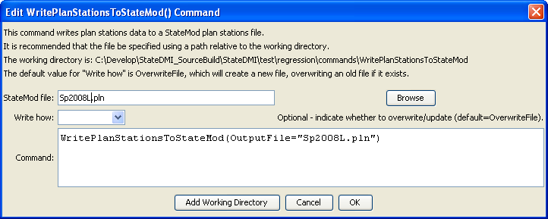
WriteOperationalRightsToStateMod
WriteOperationalRightsToStateMod() Command Editor

The command syntax is as follows:

WriteOperationalRightsToStateMod(Parameter=Value,…)

Command Parameters

Parameter | Description | Default
OutputFile | The name of the output file to write, surrounded by double quotes. | None – must be specified.
WriteHow | OverwriteFile if the file should be overwritten or UpdateFile if the file should be updated, resulting in the previous header being carried forward. | OverwriteFile

