Command Reference: WritePenmanMonteithToList()

Write Penman-Monteith crop coefficients data to a delimited file

StateCU Command
Version 3.10.00, 2010-04-02

The WritePenmanMonteithToList() command writes Penman-Monteith crop coefficients data to a delimited file. The following dialog is used to edit the command and illustrates the syntax of the command.

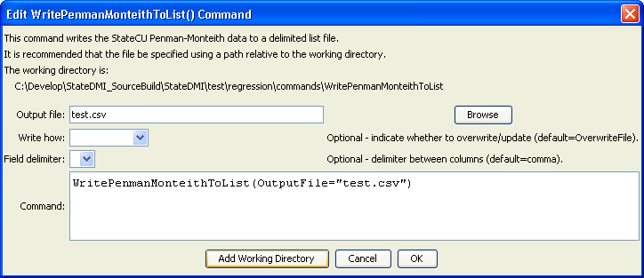
WritePenmanMonteithToList
WritePenmanMonteithToList() Command Editor

The command syntax is as follows:

WritePenmanMonteithToList(Parameter=Value,…)

Command Parameters

Parameter | Description | Default
OutputFile | The name of the output file to write, surrounded by double quotes. | None – must be specified.
WriteHow | OverwriteFile if the file should be overwritten or UpdateFile if the file should be updated, resulting in the previous header being carried forward. | OverwriteFile
Delimiter | The delimiter character to use between columns. | Comma

The following example illustrates how to process crop characteristics data from HydroBase:

ReadPenmanMonteithFromHydroBase(PenmanMonteithMethod="PENMAN-MONTEITH_ALFALFA")
WritePenmanMonteithToList(OutputFile="test.csv")

