Command Reference: WritePenmanMonteithToStateCU()

Write Penman-Monteith crop coefficients data to a StateCU file

StateCU Command
Version 3.10.00, 2010-04-02

The WritePenmanMonteithToStateCU() command writes Penman-Monteith crop coefficients that have been defined to a StateCU Penman-Monteith crop coefficients file.

The following dialog is used to edit the command and illustrates the syntax of the command.

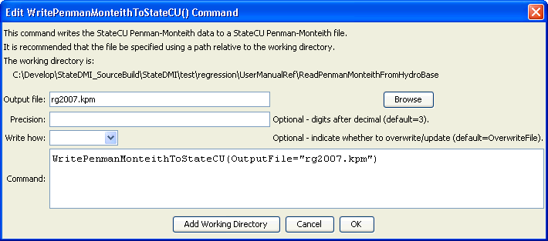
WritePenmanMonteithToStateCU
WritePenmanMonteithToStateCU() Command Editor

The command syntax is as follows:

WritePenmanMonteithToStateCU(Parameter=value,…)

Command Parameters

Parameter | Description | Default
OutputFile | The name of the output file to write, surrounded by double quotes. | None – must be specified.
Precision | The number of digits after the decimal for curve values, used for backward compatibility with older file versions. | 3
WriteHow | OverwriteFile if the file should be overwritten or UpdateFile if the file should be updated, resulting in the previous header being carried forward. | OverwriteFile

The following example command file illustrates how to read Penman-Monteith coefficients from HydroBase, sort the data, create a StateCU file, and check the results:

StartLog(LogFile="Crops_KPM.StateDMI.log")
#
# StateDMI commands to create the Penman-Monteith crop coefficients file
#
# Step 1 - read data from HydroBase
#
# Read the general ASCE standardized coefficients
ReadPenmanMonteithFromHydroBase(PenmanMonteithMethod="PENMAN-MONTEITH_ALFALFA")
#
# Step 3 - write the file
#
SortPenmanMonteith()
WritePenmanMonteithToStateCU(OutputFile="rg2007.kpm")
#
# Check the results
#
CheckPenmanMonteith(ID="*")
WriteCheckFile(OutputFile="Crops_KPM.StateDMI.check.html")

