Command Reference: WriteReservoirReturnToStateMod()

Write reservoir return data to a StateMod file

StateMod Command
Version 3.12.00, 2011-01-02

The WriteReservoirReturnToStateMod() command writes reservoir return flow data to a StateMod reservoir return flow file. The following dialog is used to edit the command and illustrates the syntax of the command.

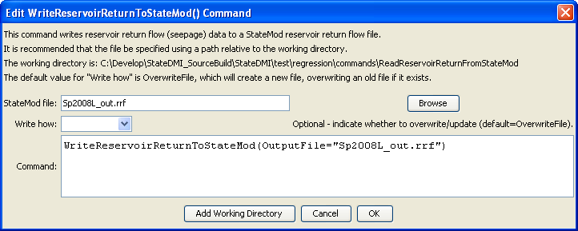
WriteReservoirReturnToStateMod
WriteReservoirReturnToStateMod() Command Editor

The command syntax is as follows:

WriteReservoirReturnToStateMod(Parameter=Value,…)

Command Parameters

Parameter | Description | Default
OutputFile | The name of the output file to write, surrounded by double quotes. | None – must be specified.
WriteHow | OverwriteFile if the file should be overwritten or UpdateFile if the file should be updated, resulting in the previous header being carried forward. | OverwriteFile

