Command Reference: WriteReservoirRightsToList()

Write reservoir rights data to a delimited file

StateMod Command
Version 3.09.01, 2010-02-01

The WriteReservoirRightsToList() command writes reservoir rights data to a delimited file.

The following dialog is used to edit the command and illustrates the syntax of the command.

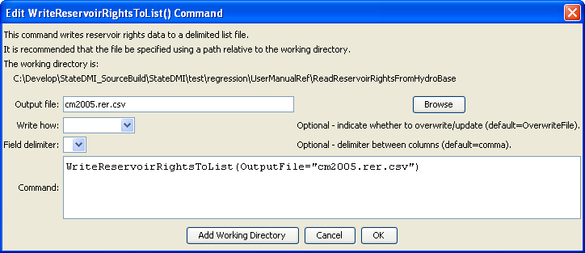
WriteReservoirRightsToList
WriteReservoirRightsToList() Command Editor

The command syntax is as follows:

WriteReservoirRightsToList(Parameter=Value,…)

Command Parameters

Parameter | Description | Default
OutputFile | The name of the output file to write, surrounded by double quotes. | None – must be specified.
WriteHow | OverwriteFile if the file should be overwritten or UpdateFile if the file should be updated, resulting in the previous header being carried forward. | OverwriteFile
Delimiter | The delimiter character to use between columns. | Comma

The following example illustrates how to create a list of reservoir rights from a list of stations:

ReadReservoirStationsFromList(ListFile="cm2005.res.csv",IDCol=1)
ReadReservoirRightsFromHydroBase(ID="*")
WriteReservoirRightsToList(OutputFile="cm2005.rer.csv")

