Command Reference: WriteReservoirStationsToStateMod()

Write reservoir stations data to a StateMod file

StateMod Command
Version 3.09.01, 2010-02-01

The WriteReservoirStationsToStateMod() command writes reservoir stations that have been defined to a StateMod reservoir stations file. The following dialog is used to edit the command and illustrates the syntax of the command.

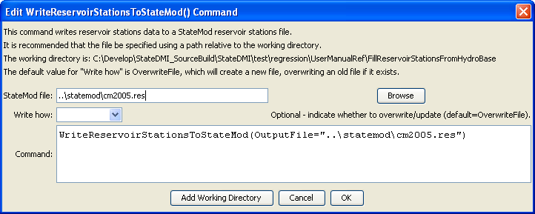
WriteReservoirStationsToStateMod
WriteReservoirStationsToStateMod() Command Editor

The command syntax is as follows:

WriteReservoirStationsToStateMod(Parameter=Value,…)

Command Parameters

Parameter | Description | Default
OutputFile | The name of the output file to write, surrounded by double quotes. | None – must be specified.
WriteHow | OverwriteFile if the file should be overwritten or UpdateFile if the file should be updated, resulting in the previous header being carried forward. | OverwriteFile

