Command Reference: WriteResponseToStateMod()

Write response data to a StateMod file

StateMod Command
Version 3.12.00, 2011-01-17

The WriteResponseToStateMod() command writes the data set file list to a StateMod response file. The following dialog is used to edit the command and illustrates the syntax of the command.

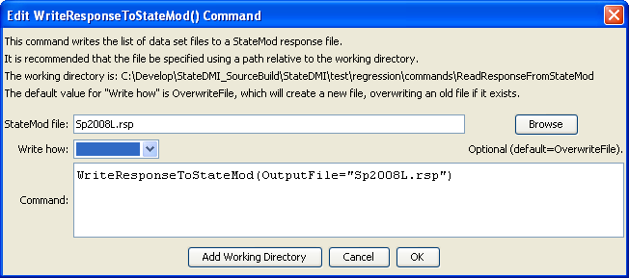
WriteResponseToStateMod
WriteResponseToStateMod() Command Editor

The command syntax is as follows:

WriteResponseToStateMod(Parameter=Value,…)

Command Parameters

Parameter | Description | Default
OutputFile | The name of the output file to write, surrounded by double quotes. | None – must be specified.
WriteHow | OverwriteFile if the file should be overwritten or UpdateFile if the file should be updated, resulting in the previous header being carried forward. | OverwriteFile

