Command Reference: WriteRiverNetworkToList()

Write river network data to a delimited file

StateMod Command
Version 3.09.01, 2010-02-01

The WriteRiverNetworkToList() command writes river network data to a delimited file. It is often more useful to write lists of individual station types. Consequently, see commands like WriteDiversionStationsToList().

The following dialog is used to edit the command and illustrates the syntax of the command.

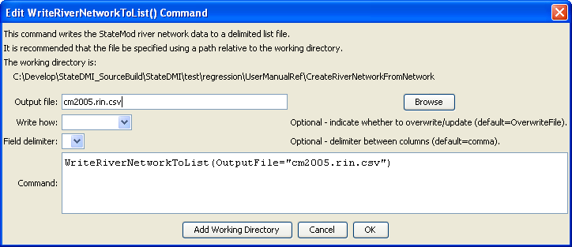
WriteRiverNetworkToList
WriteRiverNetworkToList() Command Editor

The command syntax is as follows:

WriteRiverNetworkToList(Parameter=Value,…)

Command Parameters

Parameter | Description | Default
OutputFile | The name of the output file to write, surrounded by double quotes. | None – must be specified.
WriteHow | OverwriteFile if the file should be overwritten or UpdateFile if the file should be updated, resulting in the previous header being carried forward. | OverwriteFile
Delimiter | The delimiter character to use between columns. | Comma

The following example illustrates how to create a list of river network nodes from a network file:

ReadNetworkFromStateMod(InputFile="cm2005.net")
CreateRiverNetworkFromNetwork()
WriteRiverNetworkToList(OutputFile="cm2005.rin.csv")

