Command Reference: WriteRiverNetworkToStateMod()

Write StateMod river network data to a StateMod file

StateMod Command
Version 3.09.01, 2010-02-01

The WriteRiverNetworkToStateMod() command writes the river network to a StateMod river network file. The following dialog is used to edit the command and illustrates the syntax of the command.

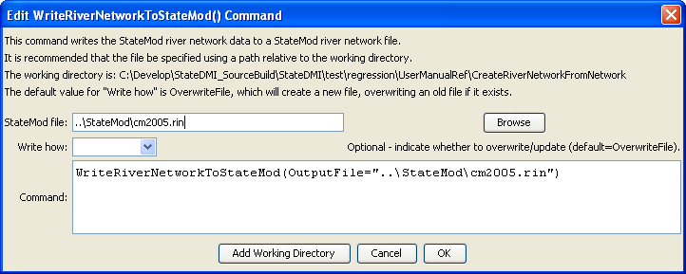
WriteRiverNetworkToStateMod
WriteRiverNetworkToStateMod() Command Editor

The command syntax is as follows:

WriteRiverNetworkToStateMod(Parameter=Value,…)

Command Parameters

Parameter | Description | Default
OutputFile | The name of the output file to write, surrounded by double quotes. | None – must be specified.
WriteHow | OverwriteFile if the file should be overwritten or UpdateFile if the file should be updated, resulting in the previous header being carried forward. | OverwriteFile

The following command file illustrates how a StateMod river network file can be created from the generalized network file:

StartLog(LogFile="rin.commands.StateDMI.log")
# rin.commands.StateDMI
#
# creates the river network file for the Colorado River monthly/daily models
#
# Step 1 - read river nodes from the network file and create file framework
#
ReadNetworkFromStateMod(InputFile="cm2005.net")
CreateRiverNetworkFromNetwork()
#
# Step 2 - get node (diversion, stream stations, reservoirs, instream flows)
# names from HydroBase
#
FillRiverNetworkFromHydroBase(ID="*",NameFormat=StationName_NodeType)
#
# Step 3 - read missing node names from network file
#
FillRiverNetworkFromNetwork(ID="*",NameFormat="StationName_NodeType",
CommentFormat="StationID")
#
# Step 4 - create StateMod river network file
#
WriteRiverNetworkToStateMod(OutputFile="..\StateMod\cm2005.rin")
#
# Check the results
CheckRiverNetwork(ID="*")
WriteCheckFile(OutputFile="rin.commands.StateDMI.check.html")

