Command Reference: WriteStreamEstimateCoefficientsToList()

Write stream estimate coefficients data to a delimited file

StateMod Command
Version 3.09.01, 2010-02-01

The WriteStreamEstimateCoefficientsToList() command writes stream estimate coefficient data to a delimited file. The following dialog is used to edit the command and illustrates the syntax of the command.

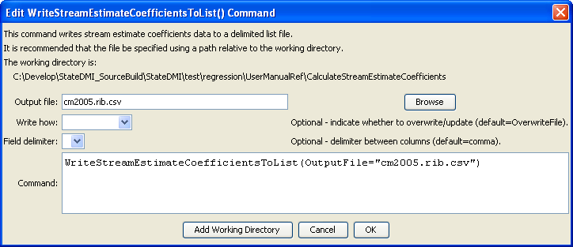
WriteStreamEstimateCoefficientsToList
WriteStreamEstimateCoefficientsToList() Command Editor

The command syntax is as follows:

WriteStreamEstimateCoefficientsToList(Parameter=Value,…)

Command Parameters

Parameter | Description | Default
OutputFile | The name of the output file to write, surrounded by double quotes. | None – must be specified.
WriteHow | OverwriteFile if the file should be overwritten or UpdateFile if the file should be updated, resulting in the previous header being carried forward. | OverwriteFile
Delimiter | The delimiter character to use between columns. | Comma

