Command Reference: WriteStreamEstimateCoefficientsToStateMod()

Write stream estimate coefficients data to a StateMod file

StateMod Command
Version 3.09.01, 2010-02-01

The WriteStreamEstimateCoefficientsToStateMod() command writes stream estimate coefficients that have been defined to a StateMod stream estimate coefficients file. The following dialog is used to edit the command and illustrates the syntax of the command.

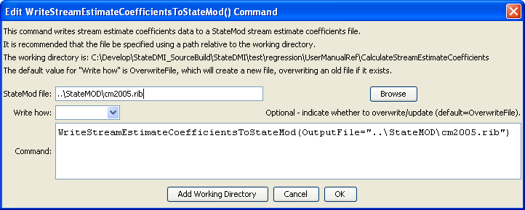
WriteStreamEstimateCoefficientsToStateMod
WriteStreamEstimateCoefficientsToStateMod() Command Editor

The command syntax is as follows:

WriteStreamEstimateCoefficientsToStateMod(Parameter=Value,…)

Command Parameters

Parameter | Description | Default
OutputFile | The name of the output file to write, surrounded by double quotes. | None – must be specified.
WriteHow | OverwriteFile if the file should be overwritten or UpdateFile if the file should be updated, resulting in the previous header being carried forward. | OverwriteFile

The following command file illustrates how a StateMod stream estimate coefficients file can be created:

StartLog(LogFile="rib.commands.StateDMI.log")
# rib.commands.StateDMI
#
# Creates the Stream Estimate Station Coefficient Data file
#
# Step 1 - read river nodes from the network file and create file framework
#
ReadStreamEstimateStationsFromNetwork(InputFile="..\Network\cm2005.net")
#
# Step 2 - set preferred gages for "neighboring" gage approach
# this baseflow nodes are generally on smaller non-gaged tribs and have
# different flow characteristics than next downstream gages
#
SetStreamEstimateCoefficientsPFGage(ID="360645",GageID="09055300")
SetStreamEstimateCoefficientsPFGage(ID="360801",GageID="09055300")
SetStreamEstimateCoefficientsPFGage(ID="362002",GageID="09054000")
SetStreamEstimateCoefficientsPFGage(ID="360829",GageID="09047500")
..similar commands omitted…
#
# Step 3 - calculate stream coefficients
CalculateStreamEstimateCoefficients()
#
# Step 4 - set proration factors directly
#
SetStreamEstimateCoefficients(ID="364512",ProrationFactor=1.000,IfNotFound=Warn)
SetStreamEstimateCoefficients(ID="374641",ProrationFactor=0.200,IfNotFound=Warn)
SetStreamEstimateCoefficients(ID="374648",ProrationFactor=0.350,IfNotFound=Warn)
SetStreamEstimateCoefficients(ID="380880",ProrationFactor=1.000,IfNotFound=Warn)
SetStreamEstimateCoefficients(ID="381594",ProrationFactor=0.800,IfNotFound=Warn)
SetStreamEstimateCoefficients(ID="384617",ProrationFactor=0.700,IfNotFound=Warn)
SetStreamEstimateCoefficients(ID="510639",ProrationFactor=1.000,IfNotFound=Warn)
SetStreamEstimateCoefficients(ID="514603",ProrationFactor=0.800,IfNotFound=Warn)
SetStreamEstimateCoefficients(ID="514620",ProrationFactor=1.000,IfNotFound=Warn)
SetStreamEstimateCoefficients(ID="510728",ProrationFactor=1.000,IfNotFound=Warn)
SetStreamEstimateCoefficients(ID="530555",ProrationFactor=0.180,IfNotFound=Warn)
SetStreamEstimateCoefficients(ID="530678",ProrationFactor=0.230,IfNotFound=Warn)
SetStreamEstimateCoefficients(ID="531082",ProrationFactor=1.000,IfNotFound=Warn)
SetStreamEstimateCoefficients(ID="954683",ProrationFactor=0.400,IfNotFound=Warn)
#
# Step 5 - create streamflow estimate coefficient file
#
WriteStreamEstimateCoefficientsToStateMod(OutputFile="..\StateMOD\cm2005.rib")
#
# Check the results
CheckStreamEstimateCoefficients(ID="*")
WriteCheckFile(OutputFile="rib.commands.StateDMI.check.html")

