Command Reference: WriteStreamEstimateStationsToList()

Write stream estimate station data to a delimited file

StateMod Command
Version 3.09.01, 2010-02-01

The WriteStreamEstimateStationsToList() command writes stream estimate stations data to a delimited file. The following dialog is used to edit the command and illustrates the syntax of the command.

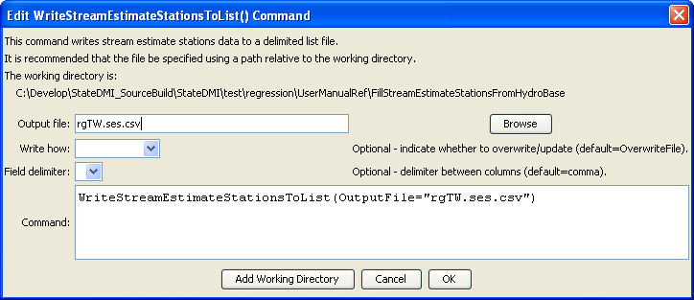
WriteStreamEstimateStationsToList
WriteStreamEstimateStationsToList() Command Editor

The command syntax is as follows:

WriteStreamEstimateStationsToList(Parameter=Value,…)

Command Parameters

Parameter | Description | Default
OutputFile | The name of the output file to write, surrounded by double quotes. | None – must be specified.
WriteHow | OverwriteFile if the file should be overwritten or UpdateFile if the file should be updated, resulting in the previous header being carried forward. | OverwriteFile
Delimiter | The delimiter character to use between columns. | Comma

The following example illustrates how to create a list of stream estimate stations from a network file:

ReadStreamEstimateStationsFromNetwork(InputFile="rgTW.net")
WriteStreamEstimateStationsToList(OutputFile="rgTW.ses.csv")

