Command Reference: WriteStreamGageStationsToStateMod()

Write stream gage stations data to a StateMod file

StateMod Command
Version 3.09.01, 2010-02-01

The WriteStreamGageStationsToStateMod() command writes stream gage stations that have been defined to a StateMod stream gage stations file. The following dialog is used to edit the command and illustrates the syntax of the command.

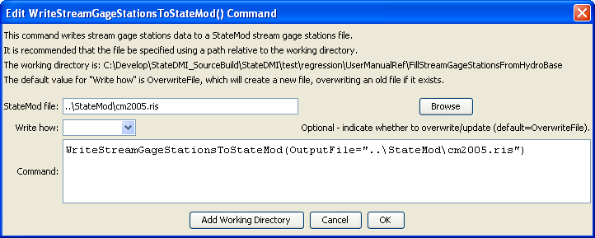
WriteStreamGageStationsToStateMod
WriteStreamGageStationsToStateMod() Command Editor

The command syntax is as follows:

WriteStreamGageStationsToStateMod(Parameter=Value,…)

Command Parameters

Parameter | Description | Default
OutputFile | The name of the output file to write, surrounded by double quotes. | None – must be specified.
WriteHow | OverwriteFile if the file should be overwritten or UpdateFile if the file should be updated, resulting in the previous header being carried forward. | OverwriteFile

The following example command file illustrates the commands used to read stream gage stations from the network and create a StateMod file:

StartLog(LogFile="ris.commands.StateDMI.log")
# ris.commands.StateDMI
#
# StateDMI command file to create streamflow station file for the Colorado River
#
# Step 1 - read streamgages and baseflows ids from the network file
#
ReadStreamGageStationsFromNetwork(InputFile="..\Network\cm2005.net",
IncludeStreamEstimateStations="True")
#
# Step 2 - read baseflow nodes names from HydroBase,
# fill in missing names from the network file
#
FillStreamGageStationsFromHydroBase(ID="*",NameFormat=StationName,CheckStructures=True)
FillStreamGageStationsFromNetwork(ID="*",NameFormat="StationName")
#
# Step 3 - set streamgage station to use to disaggregate monthly baseflows to daily
#
# add set daily pattern gages for WD 36
SetStreamGageStation(ID="36*",DailyID="09047500",IfNotFound=Warn)
…many similar commands omitted…
#
# Step 4 - create streamflow station file
#
WriteStreamGageStationsToStateMod(OutputFile="..\StateMod\cm2005.ris")
#
# Check the results
CheckStreamGageStations(ID="*")
WriteCheckFile(OutputFile="ris.commands.StateDMI.check.html")

